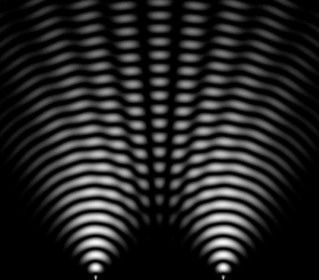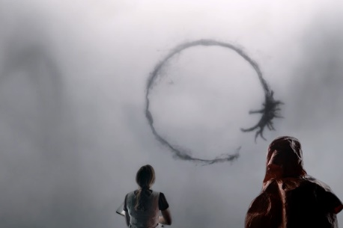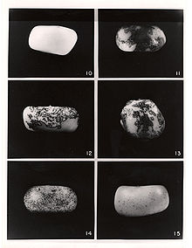

English 236: Feminist and Queer Science Studies
Professor Melody Jue
Winter Quarter 2018
Course meets: W 10am-12:30pm in SH2417
Office Hours: Th 10:30am-12pm
mjue@ucsb.edu
In the lay imagination, Science (capital S) provides objective accounts of reality that are objective precisely because they are free of the taint of human bias. The facts are out there, and scientists simply have to go out and catch them without interfering! However, accounts of science from the inside—from practitioners of science themselves—present quite a different picture. Instead of taking themselves out of the picture and achieving the distance of objectivity, the stories that scientists tell about their own discoveries show them physically immersed in their subject matter—what Nobel Prize winner Barbara McClintock called a “feeling for the organism.” It is this embodied intimacy with scientific subject matter, and the contingency of scientific discovery and articulation, that have been of particular interest to feminist and queer theory. Scholars in these fields—often with science backgrounds themselves—have sought to unfold the social and political implications of scientific ideas about kinship, variation, and mutation, and developed more situated, proximate, and partial accounts of scientific objectivity.
This introduction to feminist and queer Science and Technology Studies (STS) will begin with two views of science “in the making,” or science as told by scientists themselves: James Watson’s account of the discovery of DNA, and Barbara McClintock’s discovery of jumping genes (as told by Evelyn Fox Keller). Moving from these foundational narratives, the first half of the course will turn to work in feminist theory that examines the relationship between forms of embodied observation and objectivity (Keller, Harding, Haraway, Barad). The second half of class will consider how particular narratives about kinship, normativity, and intimacy emerge from within the practices of biology and animal studies (Subramaniam, Tallbear, Alaimo, Hayward, Chen). Our readings will explore not only what constitute feminist and/or queer critiques of science, but also the utopian impulse to imagine feminist and queer practices of science.

Required Books:
Evelyn Fox Keller, A Feeling for the Organism: The Life and Work of Barbara McClintock
James Watson, The Double Helix: A Personal Account of the Discovery and Structure of DNA
Evelyn Fox Keller, Reflections on Gender and Science
Donna Haraway, Simians, Cyborgs, and Women: The Reinvention of Nature
Karen Barad, Meeting the Universe Halfway
Banu Subramaniam, Ghost Stories for Darwin: The Science of Variation and the Politics of Diversity
Kim Tallbear, Native American DNA: Tribal Belonging and the False Promise of Genetic Science
Octavia Butler, Fledgling
Grading
Attendance/participation: 20%
Conference paper/presentation in class (5 pages): 30%
Seminar paper (15 pages): 50%
Attendance/Participation
Students earn 20% of their attendance grade per class meeting for being on time and prepared to discuss readings. Students have one free absence.
Conference Paper
On the first day of class, students will choose a week to present a short conference-style paper (5 pages, double spaced—or 10 minutes) on a topic of their choice that relates to course readings, and ideally, also their own interests. Students can elect to read their paper, or also bring visual/other media.
Seminar paper
Students should choose a final paper or project that relates to their own research interests. It can be a traditional seminar paper, or a book review essay of something published within the last 1-2 years, or an alternate idea of their choosing (in consultation with me); the only requirement is that the assignment involve the equivalent of 15 pages. You are also welcome to build on your conference paper.

Schedule
Week 0 / January 10: no class
Week 1 / January 17: (Auto)biographies of Scientific Practice
Evelyn Fox Keller, A Feeling for the Organism: The Life and Work of Barbara McClintock
James Watson, The Double Helix: A Personal Account of the Discovery and Structure of DNA
Week 2 / January 24: Objectivity
Evelyn Fox Keller, Reflections on Gender and Science
Sandra Harding, “Rethinking Standpoint Epistemology: What is ‘Strong Objectivity’?” (PDF)
Week 3 / January 31: Situated Knowledge
Donna Haraway, Simians, Cyborgs, and Women: The Reinvention of Nature
Week 4 / February 7: Multispecies
Eva Hayward, “Sensational Jellyfish: Aquarium Affects and Matters of Immersion” (PDF)
Carla Hustak and Natasha Myers, “Involutionary Momentum: Affective Ecologies and the Sciences of Plant/Insect Encounters” (PDF)
Stacy Alaimo, “Eluding Capture: The Science, Culture, and Pleasure of Queer Animals” (PDF)
Neel Ahuja, “Intimate Atmospheres: Queer Theory in a Time of Extinctions” (PDF) and “Postcolonial Critique in a Multispecies World” (PDF)
February 9: Neel Ahuja talk in South Hall
Week 5 / February 14: Language
The Arrival (dir. Denis Villaneuve)
Ted Chiang, “The Story of your Life” (PDF)
Week 6 / February 21: Agential Realism
Karen Barad, Meeting the Universe Halfway
Week 7 / February 28: Variation
Banu Subramaniam, Ghost Stories for Darwin: The Science of Variation and the Politics of Diversity
Week 8 / March 7: Indigeneity reschedule
Kim Tallbear, Native American DNA: Tribal Belonging and the False Promise of Genetic Science
Neil Banas, “Deep-water Intrusions” (PDF)
Week 9 / March 14: Intimacies
Octavia Butler, Fledgling
Jose Muñoz, Introduction to Cruising Utopia (PDF)
Mel Chen, “Toxic Animacies, Inanimate Affections” (PDF)
Final papers due by email: March 21, 2018

